Guide for Suppliers of Non-production Materials and Services

I. Classification of Suppliers of Non-production Materials and Services
Classification of Supplier | Category of Material | Name of Material
Non-production materials | Obsolete materials | Selling of obsolete materials, selling of scrapped material;
 | Office assets | Vehicle, furniture, IT equipment, home appliances, kitchenware, intangible assets, other equipment
 | General Materials | Office supplies, clothing, cleaning grocery, IT consumables, entertainment supplies, activity supplies, canteen supplies, printed products, logistics food materials, logistics materials;
Non-production services | General services | Set-up of booth, brand design, administrative services, personnel services, insurance services, logistics services, other services
II. What are the Attentions to Prepare Bidding Document?
- Bidding document: Follow the purchase requirements to prepare bidding documents. Mind that the technical bid and the commercial bid should be put in separate envelops, and keep the envelop sealed by gluing or pasting paper strips onto the openings and applying the company chop on edges of the paper strips, as shown in figure 1 and 2.
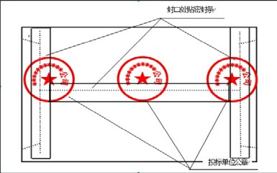
Figure 1: Example for pasting the paper strip Figure 2: Example for applying chops on the bidding document

- Location and time to submit bidding documents;
- Location and time to elaborate bidding documents;
- Methods and standards to evaluate bids.

III. What Certificates should Bidders Provide?
- Legal representative’s certificate or or Power of Attorney;
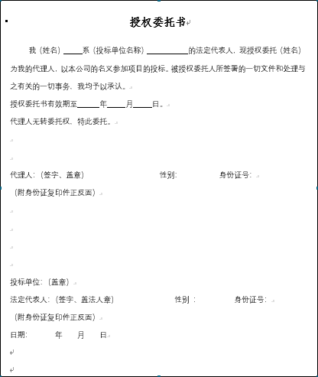
- Business license;
- Other certificates (original or copy) bidders believe necessary;
Note: The above documents provided by bidders should be true and effective, with the company chops applied on each file. Any false information will made the bid rejected and the supplier listed in LONGi’s blacklist.

IV. Bid-opening Procedure On-site
☆Announce bidding disciplines —— introduce bidding projects —— bidding steps (draw lots —— open the bid —— technical evaluation —— commercial evaluation) —— close the bidding procedure

V. Bid-opening Attentions
Suppliers engage in the bidding must comply with the principle of good faith. In case of any of the following situations, the supplier will be disqualified and included in LONGi supplier blacklist.
- A supplier provides false quotation, electronic chop or signature, fake qualification during the bidding.
- Malpractices like conspired bidding, bid-rigging.
- Unlawfully bid in other’s name during tendering or purchase process, or practice fraud to win the bid in other manners.
- Other acts in violation of LONGi’s procurement rules or the country’s laws and regulations.

VI. How to inform the bidding results?
- Send the bid-winning/losing notice via email;
- Inform the losing result via phone calls;

